1. Creating and Renaming Files/Directories
Create a directory named test_dir using mkdir.
mkdir test_dir
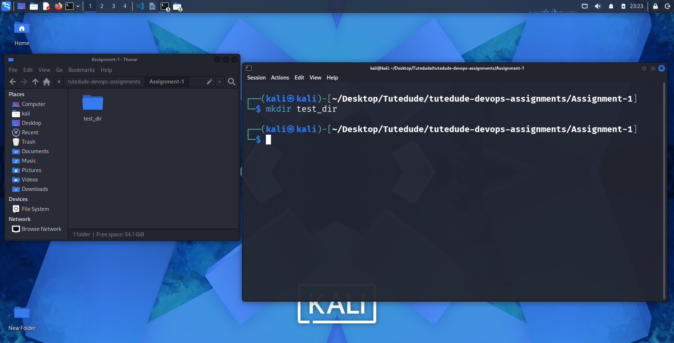
Inside test_dir, create an empty file called example.txt.
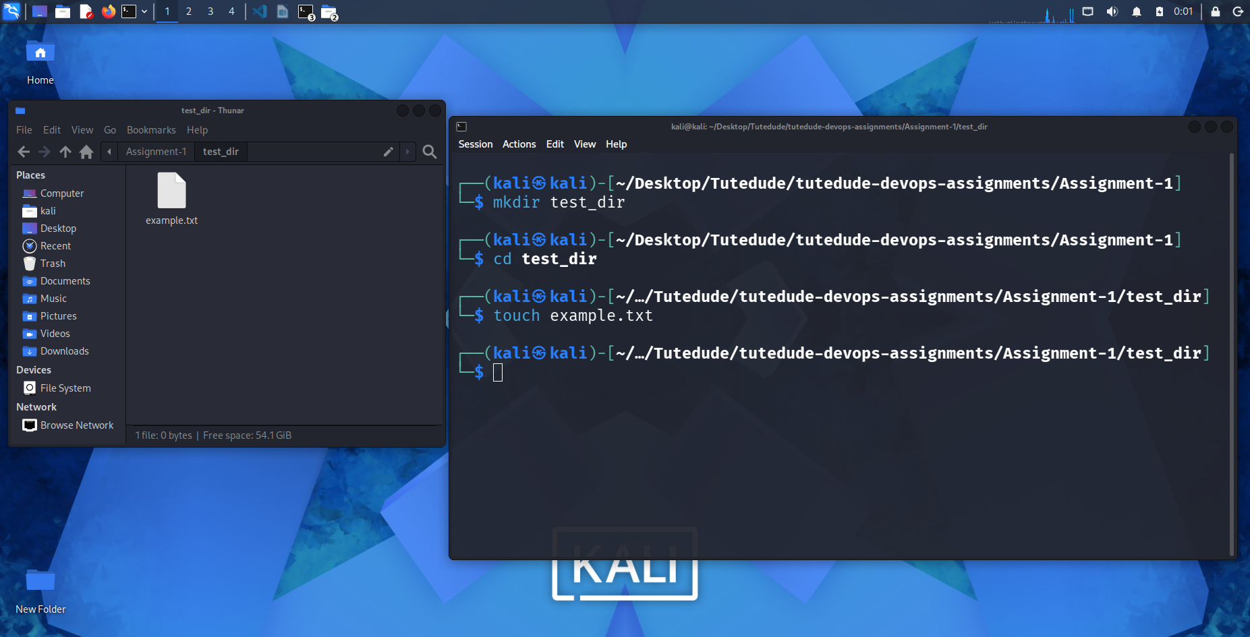
touch expample.txt
Rename example.txt to renamed_example.txt using mv
mv expample.txt renamed_expample.txt
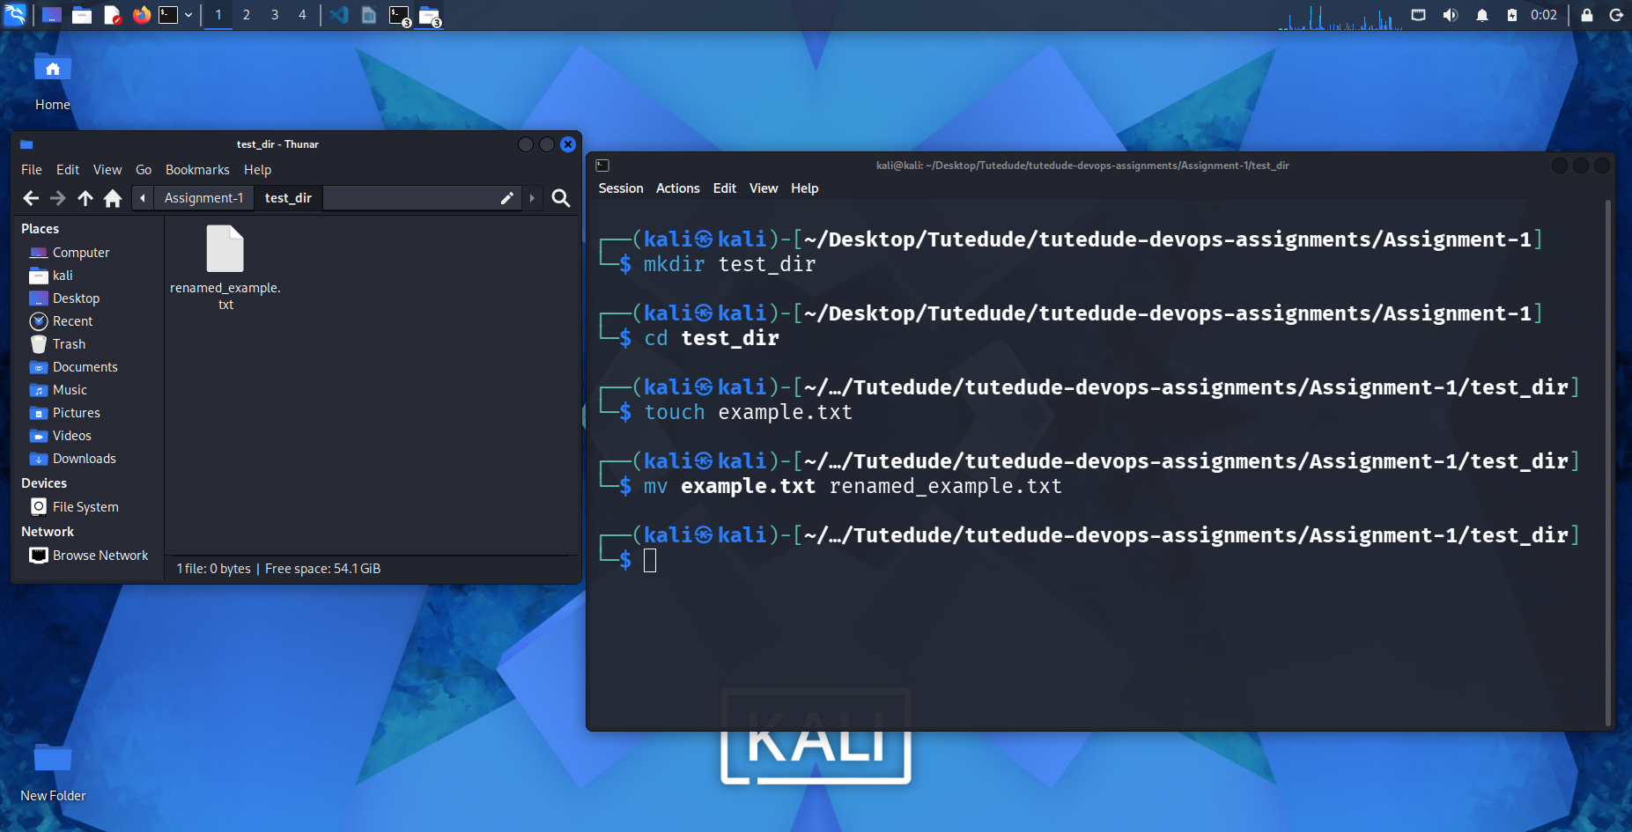

2. Viewing File Contents
Use cat to display the contents of /etc/passwd.
cat /etc/passwd
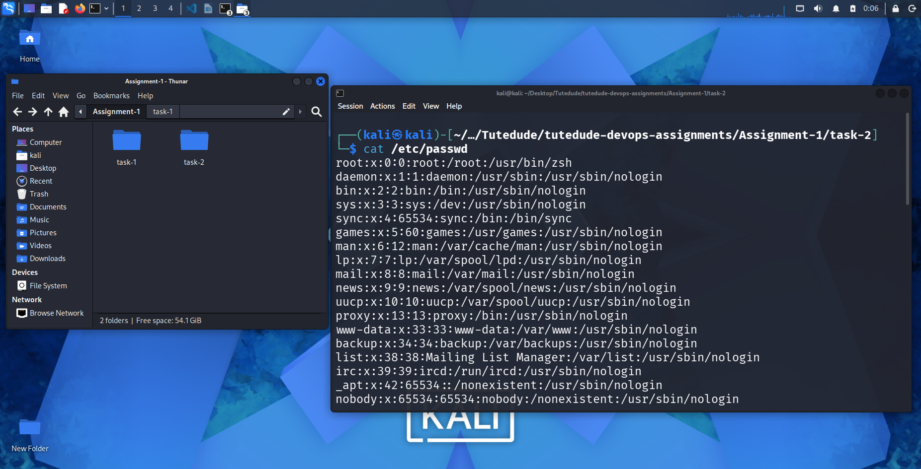
Display only the first 5 lines of /etc/passwd using head.
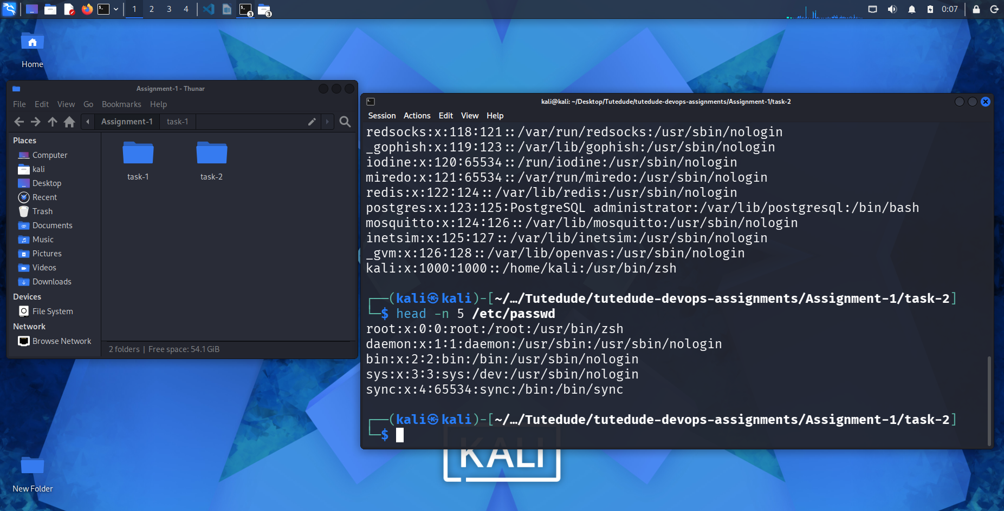
head -n 5 /etc/passwd
Display only the last 5 lines of /etc/passwd using tail.
tail -n 5 /etc/passwd
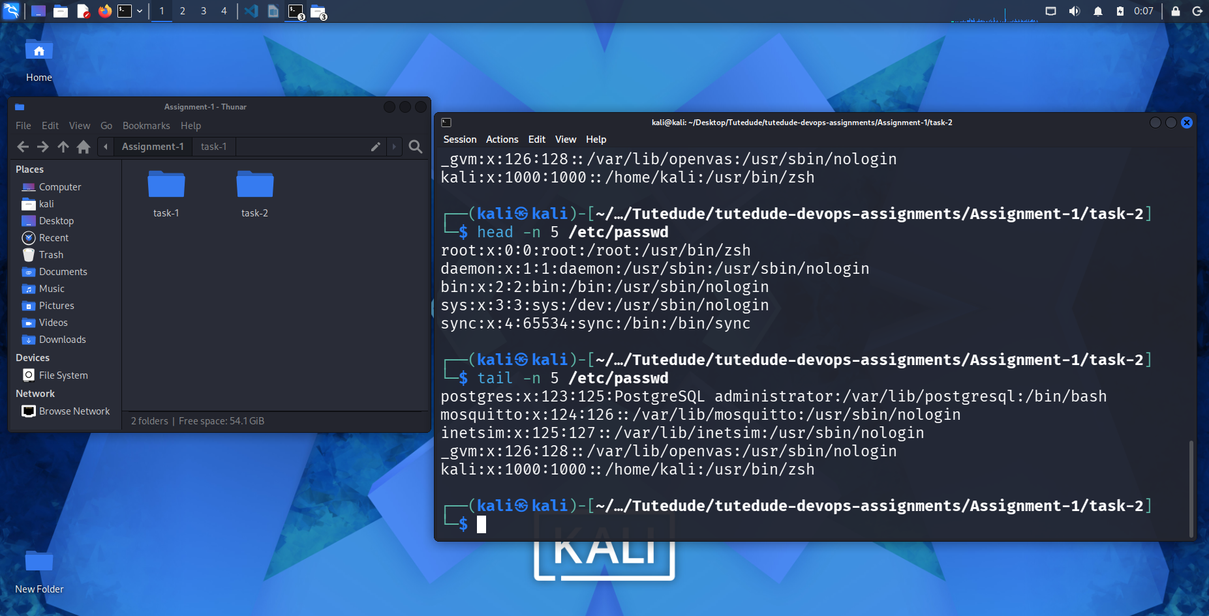

3.Searching for Patterns
Use grep to find all lines containing the word "root" in /etc/passwd.
cat /etc/passwd | grep root
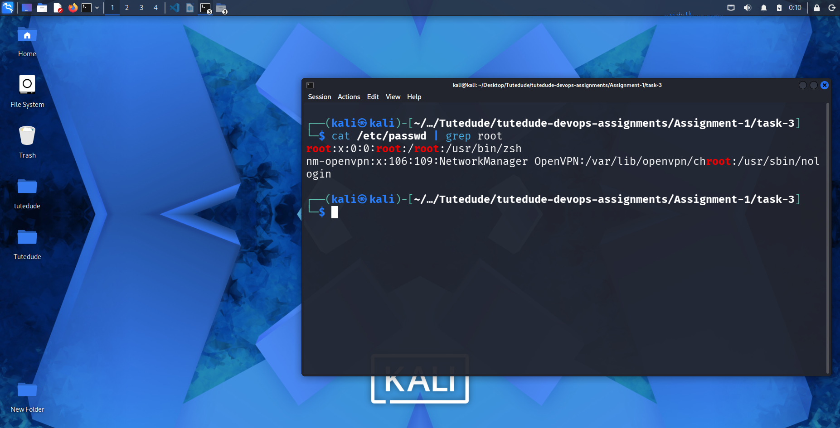

4. Zipping and Unzipping
Compress the test_dir directory into a file named test_dir.zip using zip.
zip test_dir.zip test_dir
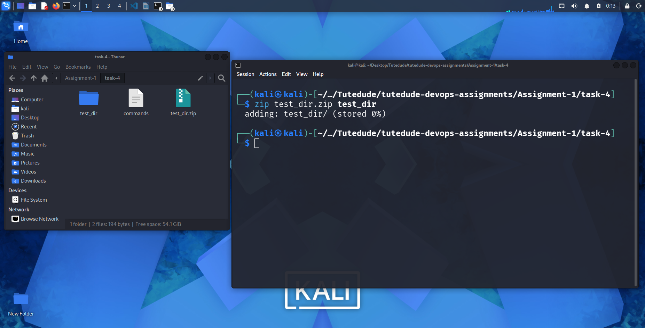
Unzip test_dir.zip into a new directory named unzipped_dir.
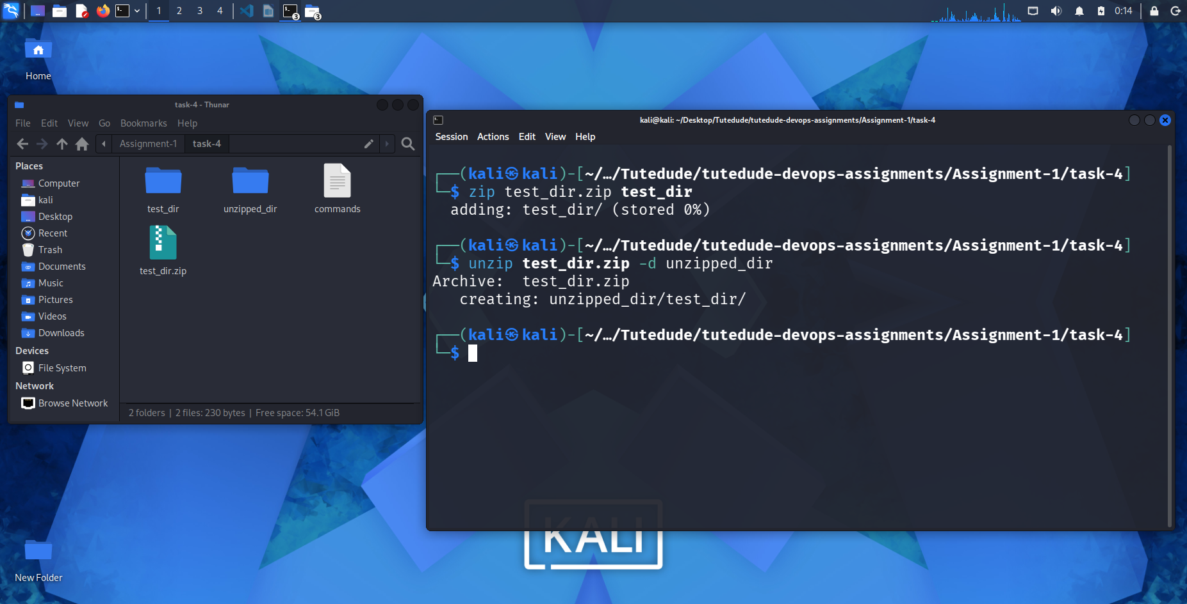
unzip test_dir.zip -d unzipped_dir
5. Downloading Files
Use wget to download a file from a URL (e.g., https://example.com/sample.txt).
wget https://example.com/sample.txt
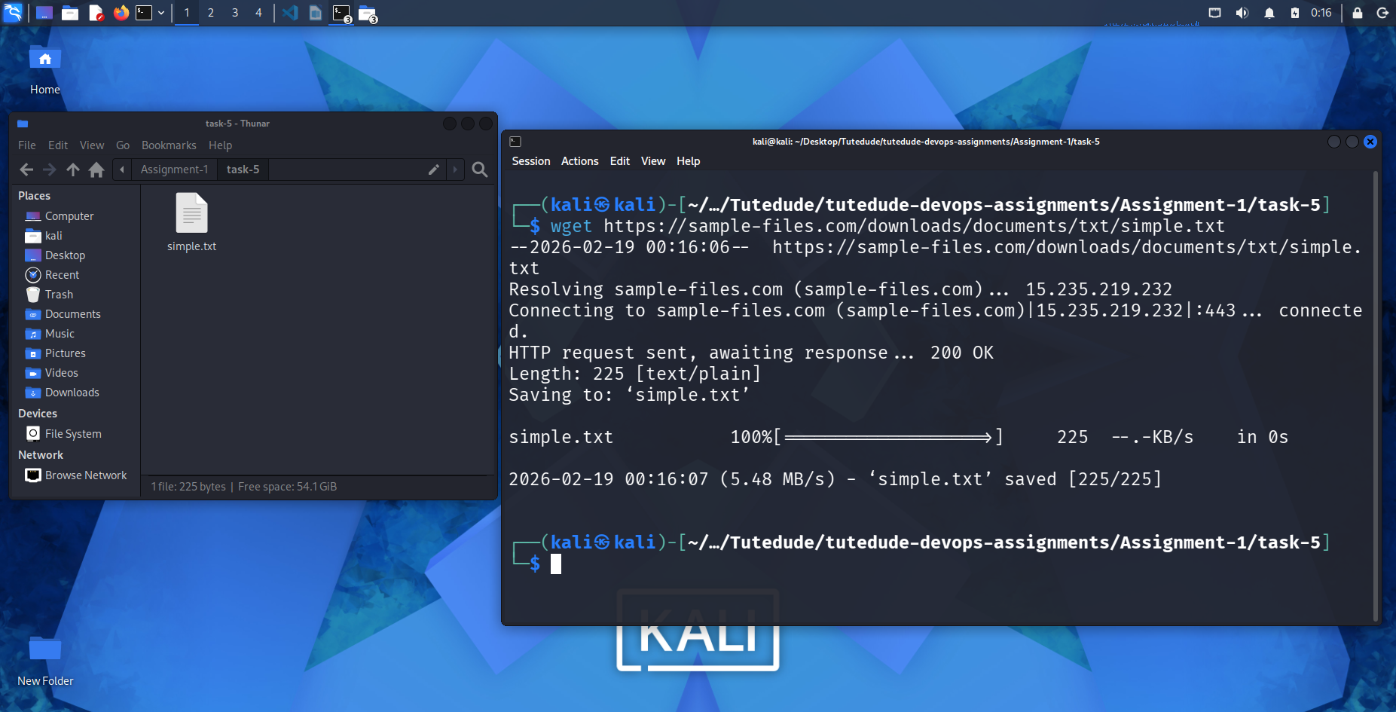

6. Changing Permissions
Create a file named secure.txt and change its permissions to read-only for everyone using chmod.
chmod 444 secure.txt
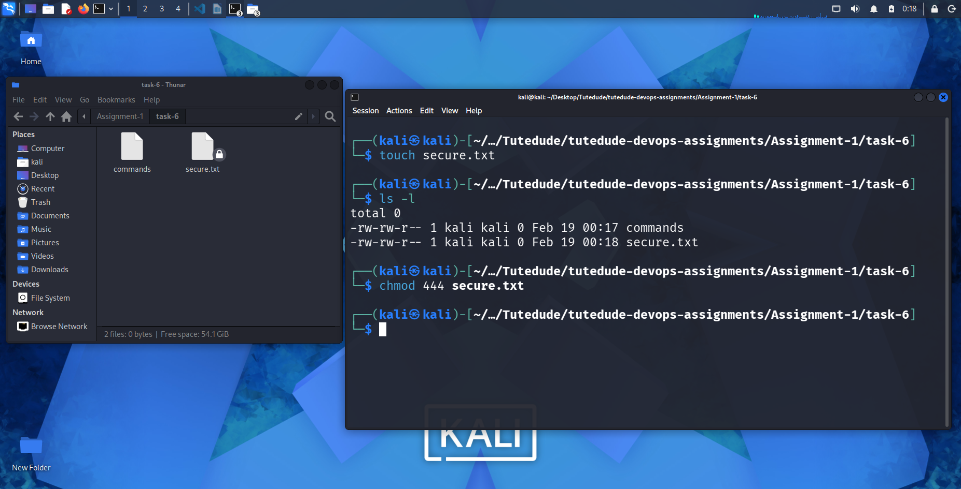
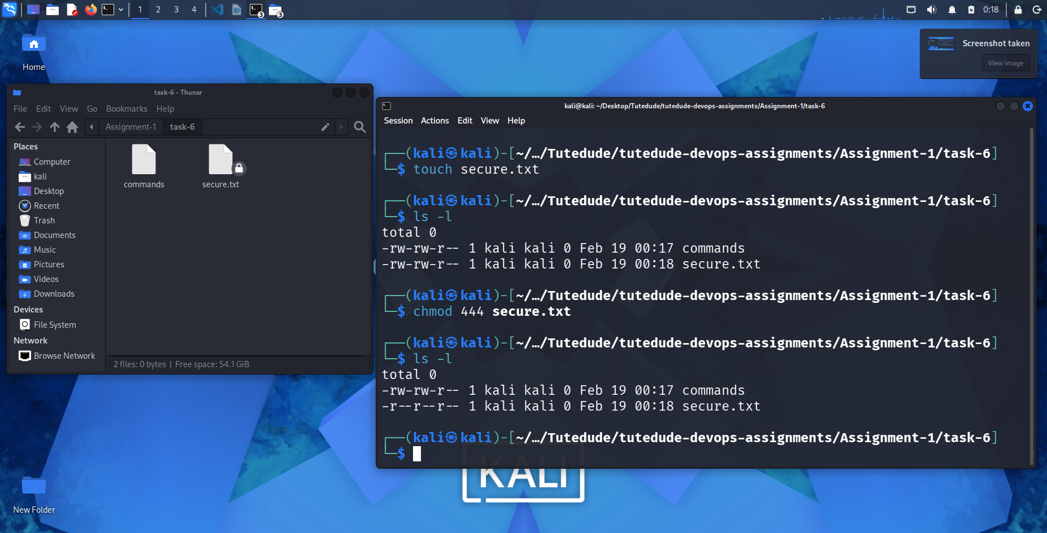

7. Working with Environment Variables
Use export to set a new environment variable called MY_VAR with the value "Hello, Linux!".
export MY_VAR="Hello, Linux!"


